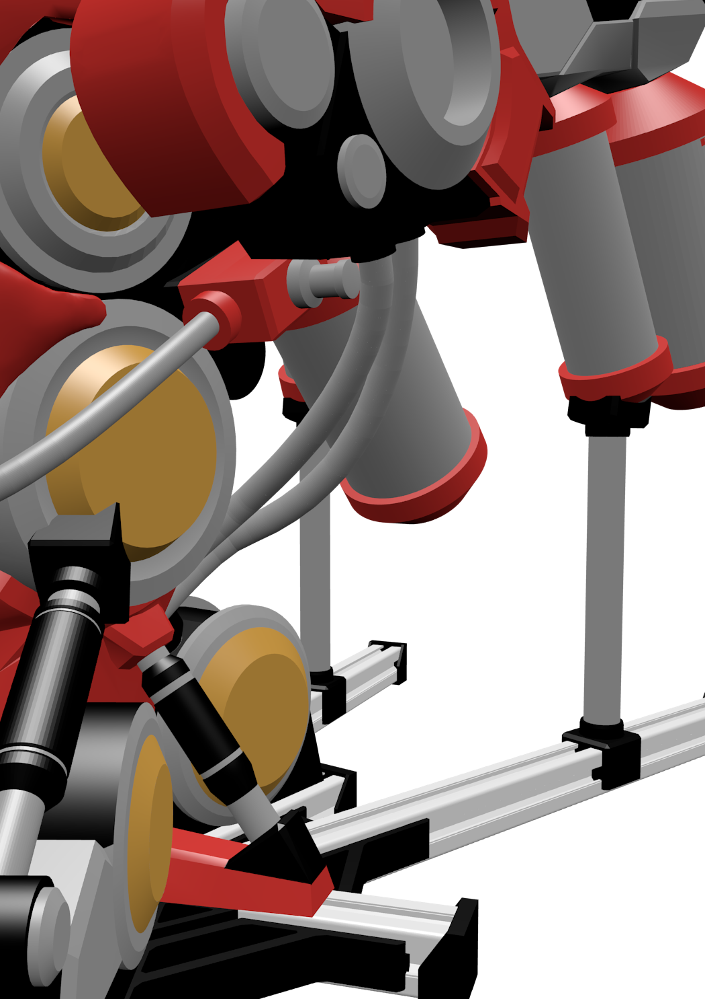

|  |
| --- |
|  |

Chemical Plant Display and Teaching Model – User Manual

Created by: Yuntian Fang Supervisor: Dr Sai Gu

Date: 6th July 2020 / Rev 2.0

# Introduction

This fully 3D printed model of a basic chemical plant is intended to be used as a display and simple teaching model with all the functionality of a real chemical plant in an aesthetically appealing package.

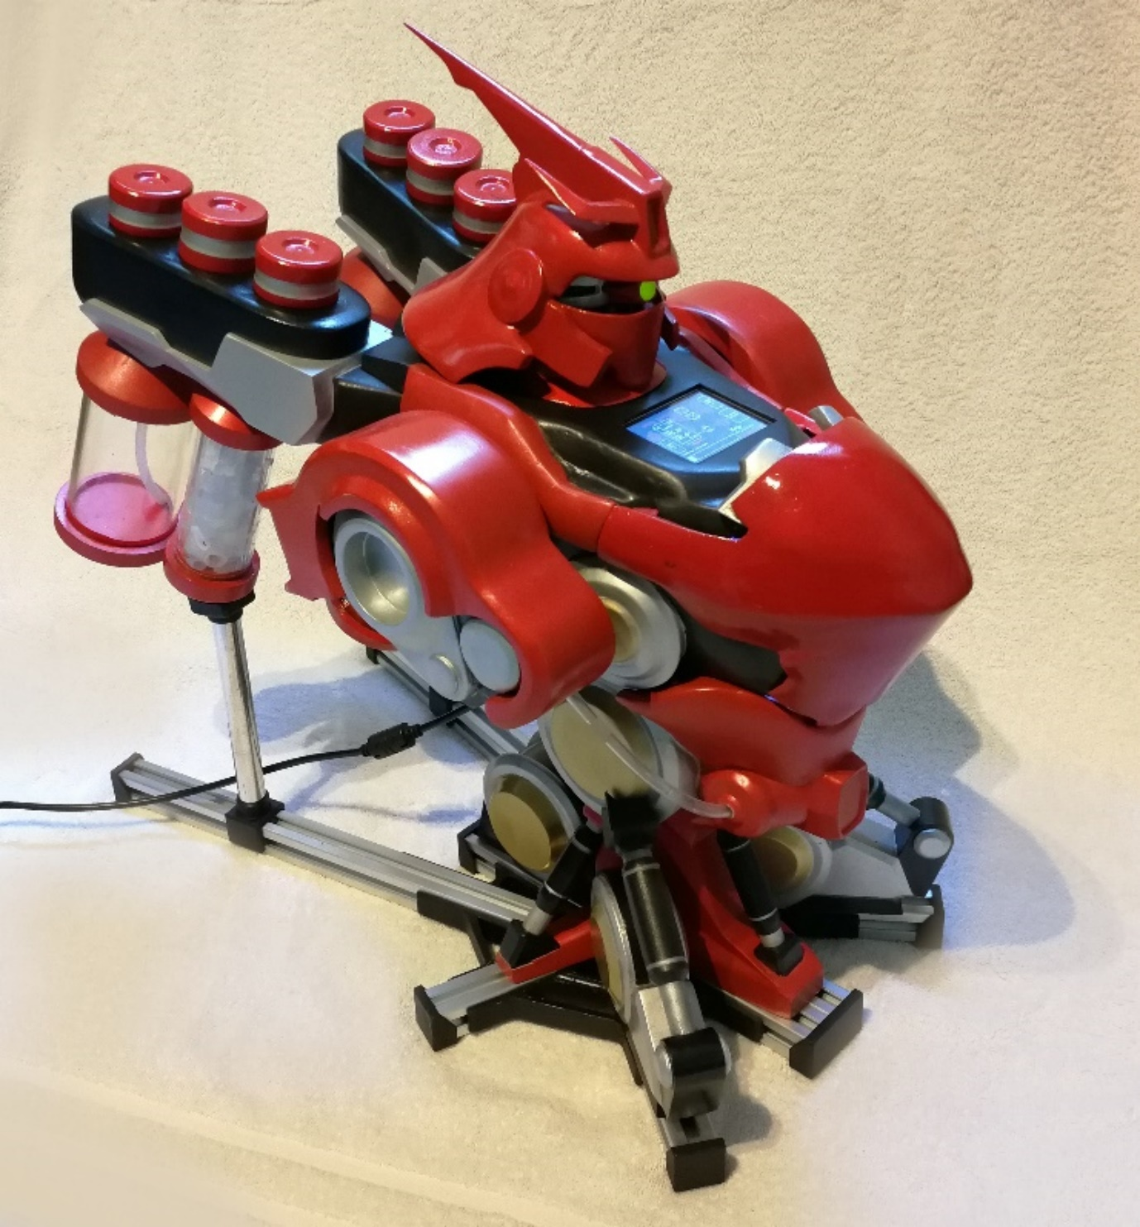Controlled by the touchscreen on the front and powered just by a generic 12V 3A mains plug, the model is entirely self-contained and is very simple to set up. It simply needs to be plugged in to power and the microprocessors will automatically begin.

Figure 1: Fully assembled model powered on. Dimensions are (WxLxH): 25cm x 50cm x 43cm.

# Functionality

The model contains following parts:

* 2 x screw feeders into the main reactor for solid-based reactants.
* 1 x liquid reactant holder with delivery to reactor vessel (removable).
* 1 x CO2 extraction vessel using a water scrubbing system.
* 1 x CO2 scrubbing water storage vessel (removable).
* 1 x Reactant storage vessel (removable).
* 1 x Reactor vessel.
  + Temperature controlled to the nearest 0.1oC.
  + Magnetic stirrer.
* USB mini output to computer.
* 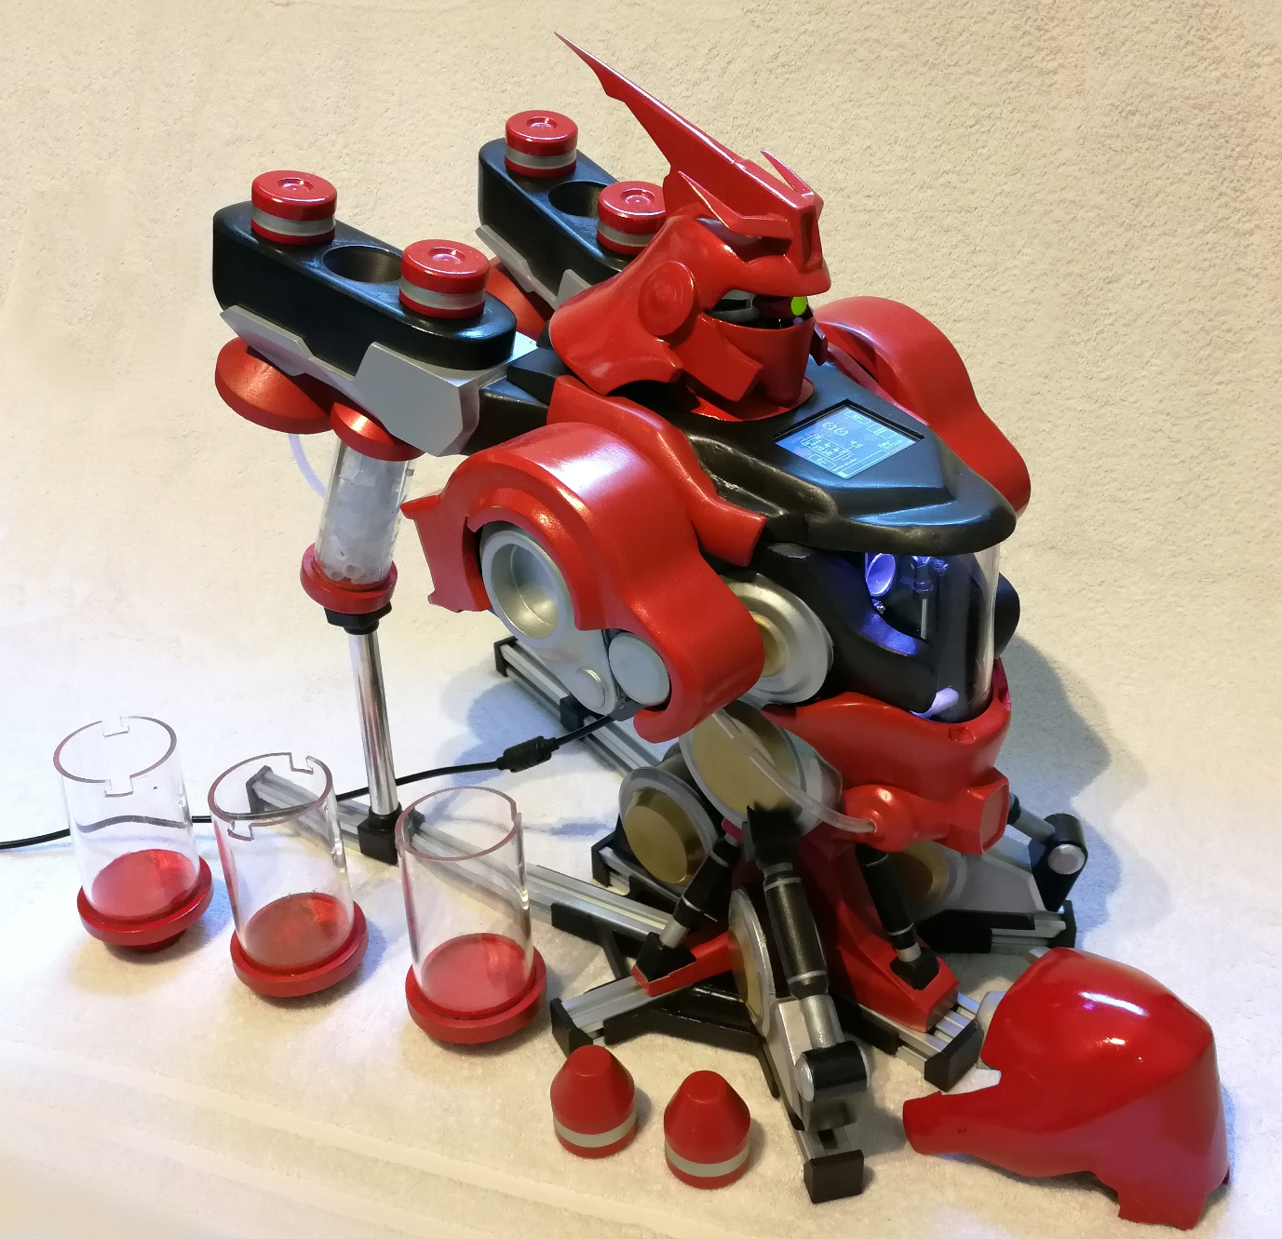2.4” touchscreen with P&ID schematic interface.

Figure 2: Model with parts removed exposing the reactor vessel and screw feeder input holes.

# Specific Areas of Interest

Figure 4: Screw feeder covers removed.

Figure 3: USB mini port and 5.5mm x 2.1mm DC barrel jack.

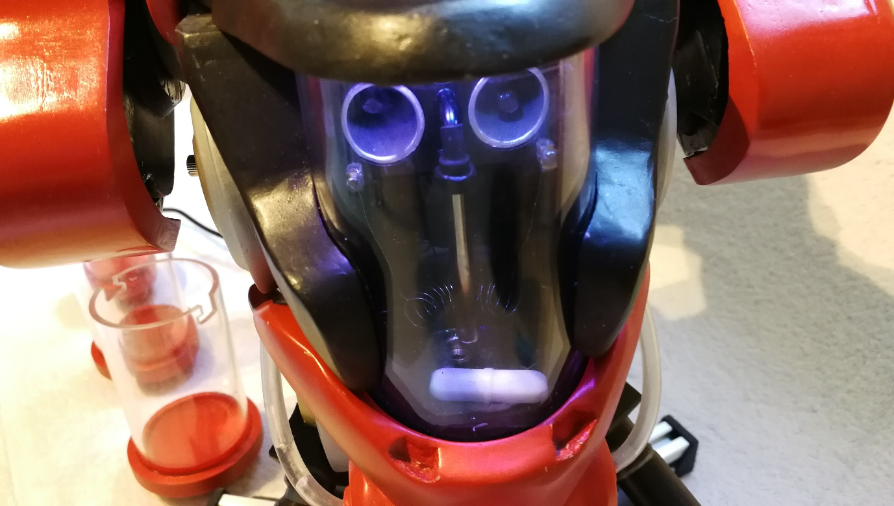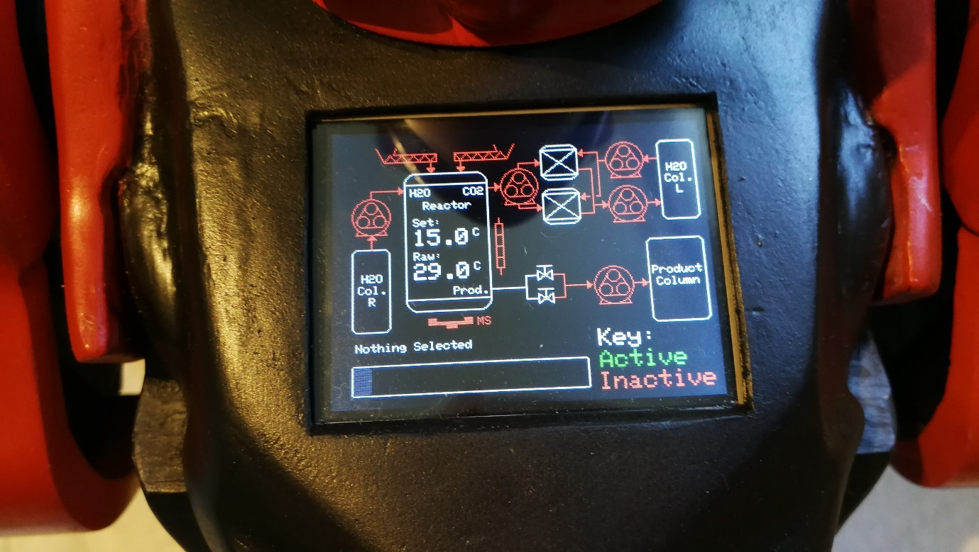

**(1)**

**(4)**

**(2)**

**(3)**

**(5)**

Figure 5: Reactor vessel with integrated heater coil, thermometer, magnetic stirrer bar and screw feeder input holes.

Figure 6: The 2.4” touchscreen control interface drawn using P&ID conventions.

# Mode of Operation

Finished

Product

Storage

Figure 7: Highlighted and labelled areas of the model.

CO2 Capture

(x2)

Pumps (x5)

Electronics

Reactor

Magnetic Stirrer

Screw Feeder (x2)

H2O Storage

(x2)

Inside the model, there are five self-priming peristaltic pumps to move liquids around and two DC motors that control the screw feeders.

As per the P&ID diagram before (figure 6),

* Pump 1 : Moves water from the H2O column on the right directly into the reactor.
* Pump 2 : Removes CO2 and transfers it to the CO2 capture column. Only the column on the left will function due to technical difficulties.
* Pump 3 : Transfers the liquid product from the reactor into the finished product storage column.
* Pump 4 : Supplies water to the CO2 scrubber from the H2O column on the left.
* Pump 5 : Returns water from CO2 scrubber back to left H2O column.

# Notes for Usage and Safety

1. Power and USB connection:
   1. Power the model with a 12V supply (±1V) with at least 3A capability through the DC barrel jack.
   2. Do NOT connect to computer without plugging into power BEFOREHAND.
   3. ALWAYS remove USB connection BEFORE removing 12V power.
   4. Failure to comply with notes 1b and 1c may cause the microcontroller to crash or other erratic behaviour not limited to permeant damage to the microcontroller and the PC it is connected to.
2. Operating pumps:
   1. Do NOT allow the following pumps to operate without supervision.
      1. Pump 1 – Moves water into the reactor.
      2. Pump 3 – Moves liquid from reactor to product storage.

These pumps control liquid flow in and out of the reactor which can overflow.

This is due to the lack of feedback systems from the additional complexity of monitoring systems and hysteresis from the relatively large volume contained inside the connecting pipes.

* 1. Pumps 4 and 5 should be operational at the same time during continuous operation and should only differ during start-up (to add some water into the capture column) and during shut down (to remove all water from the column.)
  2. Pump 2 can be operated in any situation.

1. Screw feeders:
   1. Do NOT pour liquids into the mechanism. If cleaning is needed use compressed air or other non-liquid method.
   2. Replace cover after use to prevent the screw from being jammed by any external objects that may enter.
2. Reactor and storage columns:
   1. Do NOT allow reactor to overflow.
   2. Empty them out after purging all water from system.
   3. Do NOT set the heater temperature to higher than raw without water present in the reactor.
   4. Do NOT allow water or fluids to remain in the reactor or storage columns for over 48 hours at a time.
3. Top cover
   1. Can be removed and replaced to expose internals. Held on by friction. May require a gentle push to lock into place. Do not force.

# Start-up Sequence

1. Connect 12V DC power .
2. Connect to PC with mini USB (optional).
3. Remove and fill left and right water storage column with water. Fill to around ¾ of the way since when attached to the model the storage column will be angled.
4. Ensure the finished product storage column is attached to the back.
5. Activate pump 4 and pump 5 to begin the circulation of water in the CO2 scrubber column.
6. Activate pump 2 removing CO2 from the reactor and moving it to the CO2 scrubber column.
7. Close valves located on the sides.
8. Activate pump 1 to pump water from the water column on the right to the reactor.
9. Visually monitor the filling process. Deactivate pump 1 when the waterline reaches halfway.
10. Activate the magnetic stirrer and increase the set temperature. Do NOT increase the set temperature without there being water inside the reactor.
11. Remove the screw feeder caps and activate the screw feeder.
12. Pour reactant powder into screw feeder and deactivate screw feeder when reactant powder is all inside reactor.

# Shutdown Sequence

1. Deactivate set temperature by dragging the bar to the very left (set to 15oC) and deactivate the magnetic stirrer.
2. Open valves located on the sides.
3. Activate pump 3 to transfer the liquid from the reactor to the finished product storage column. Stop pump when liquid is drained from reactor.
4. Deactivate pump 2 which transfers CO2 from the reactor to the CO2 scrubber column.
5. Deactivate pump 4 and leave pump 5 running. This is to remove all the water from the CO2 scrubber. Turn off pump 5 when no water remains.
6. Once all liquids have been transferred into the storage columns, remove them and empty them out.
7. Leave to dry top-up.
8. Remove USB cable
9. Remove 12V DC power.

# Design and Electronics

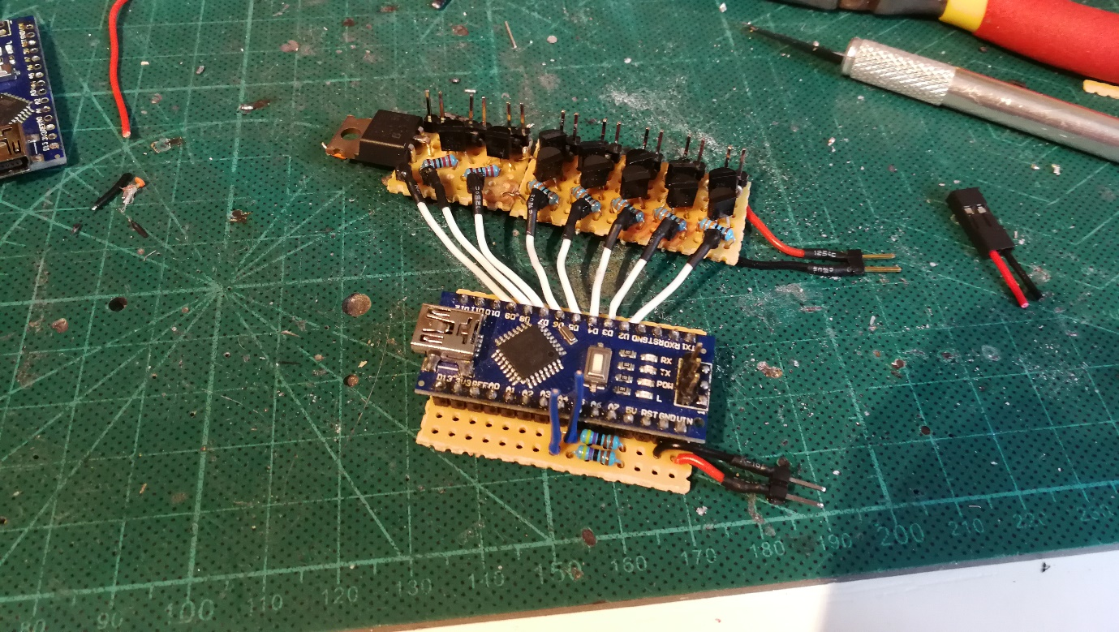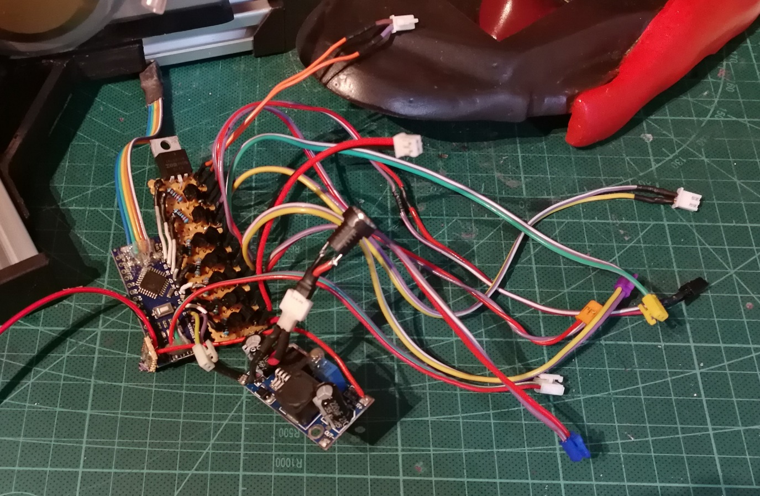Below details the electronics and the construction of the model.

Figure 8: Pump and motor driver board connected to an Arduino Nano.

Figure 9: Control electronics with removable connectors and power converter.

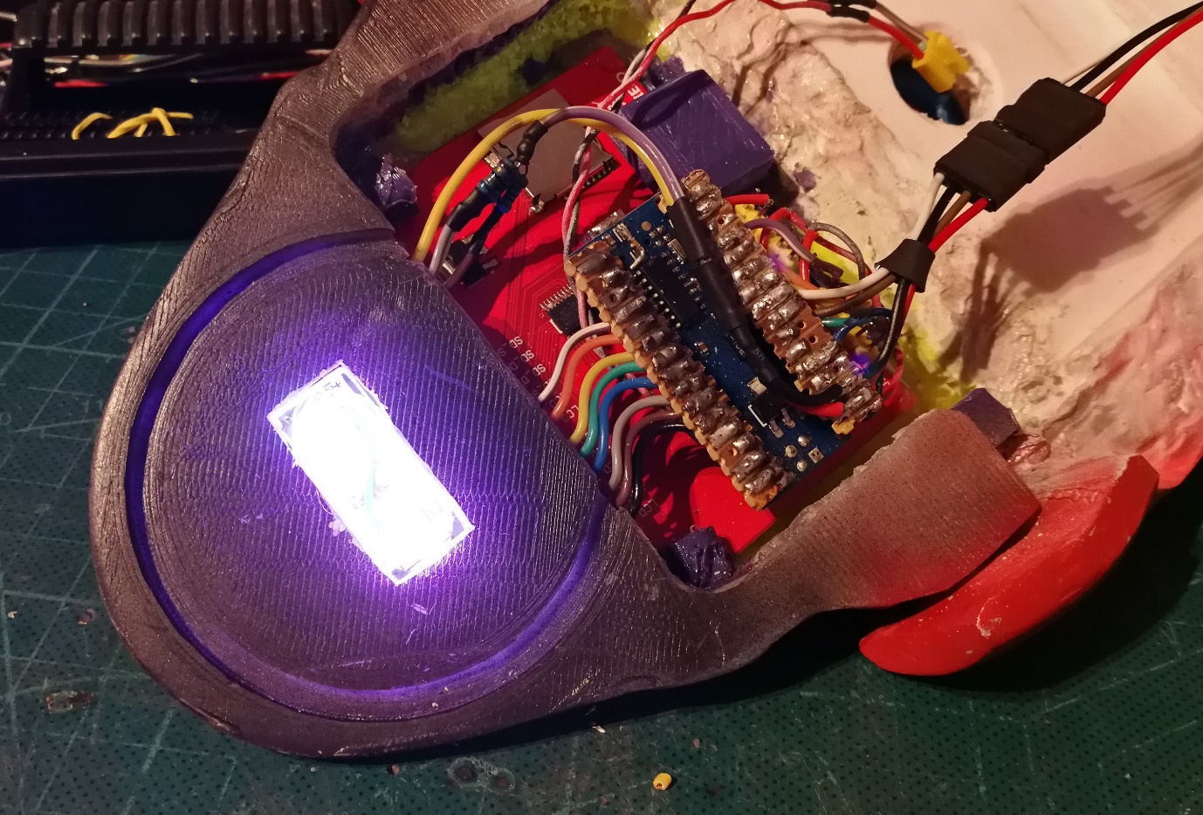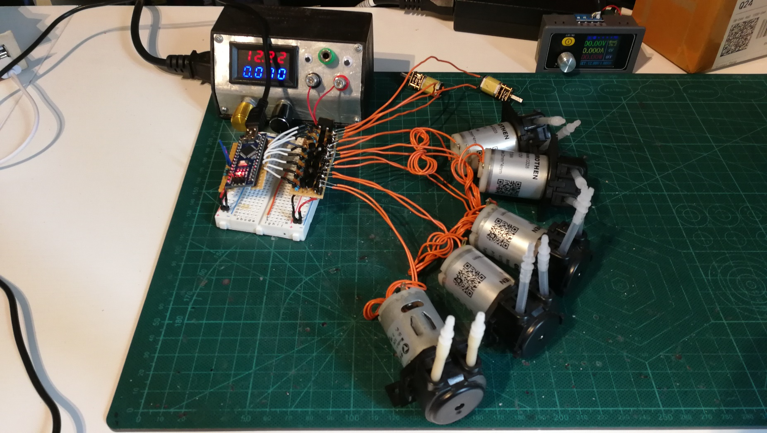

Figure 10: Testing the control board connected to all 5 peristaltic pumps and 2 screw feed motors.

Figure 11: Additional Arduino Nano controlling the touchscreen display. Lights for illuminating reactor.

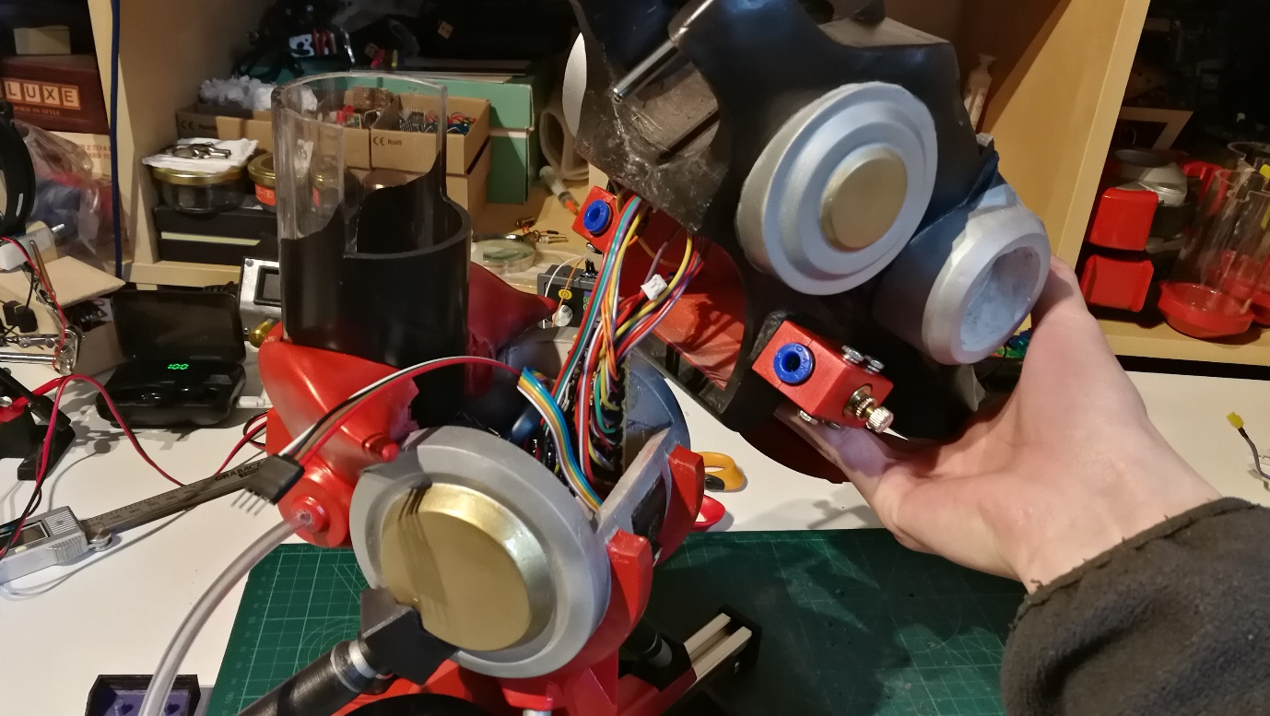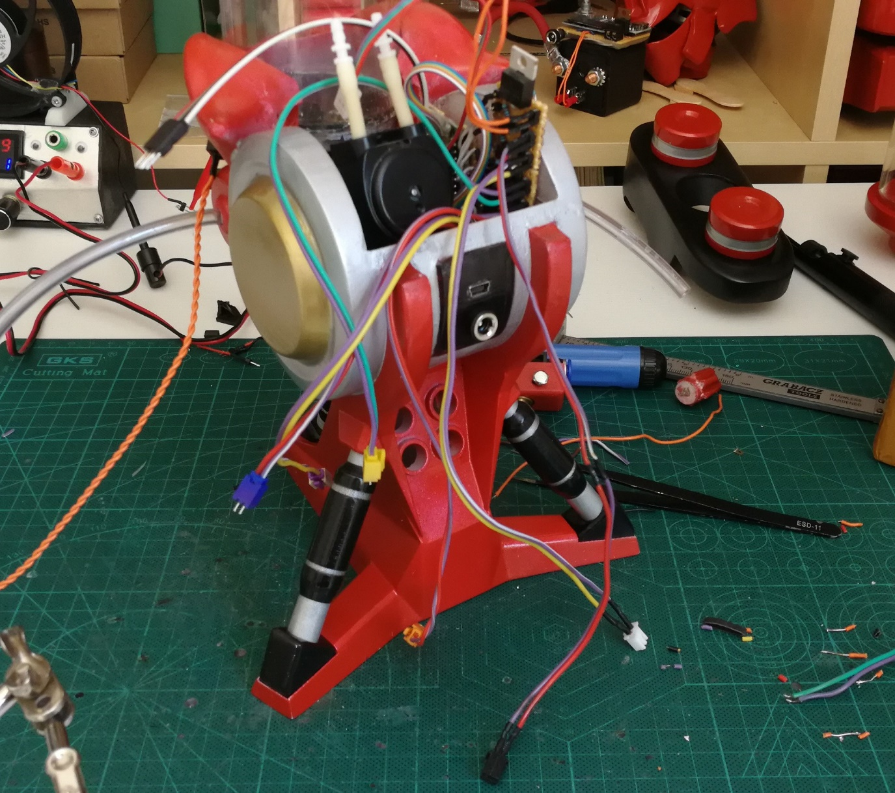

Figure 12: Fitting all the electronics into the model.

Figure 13: Placing top cover over the electronics to seal them in place.

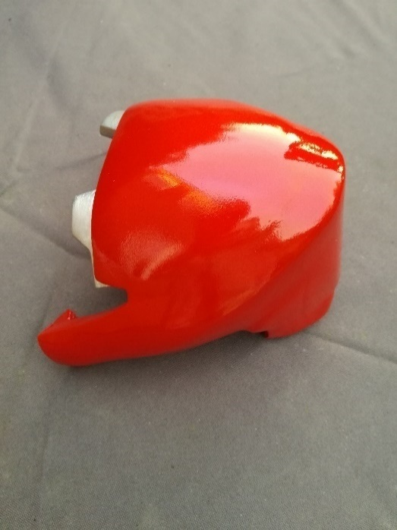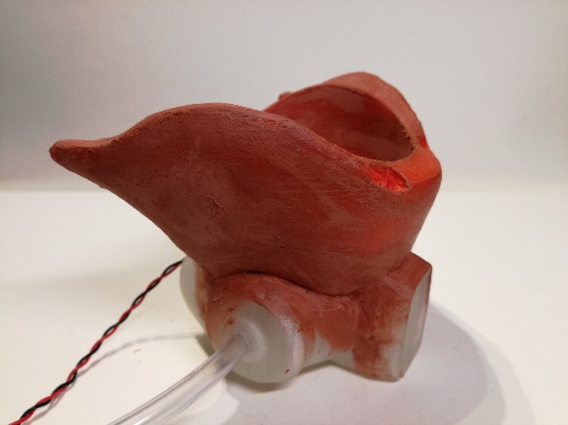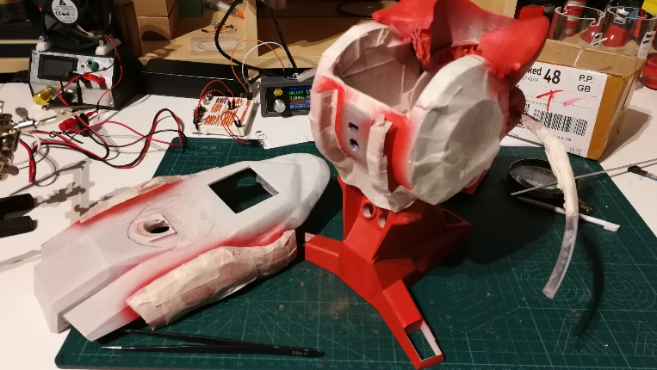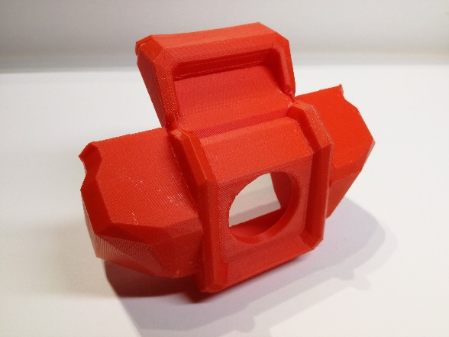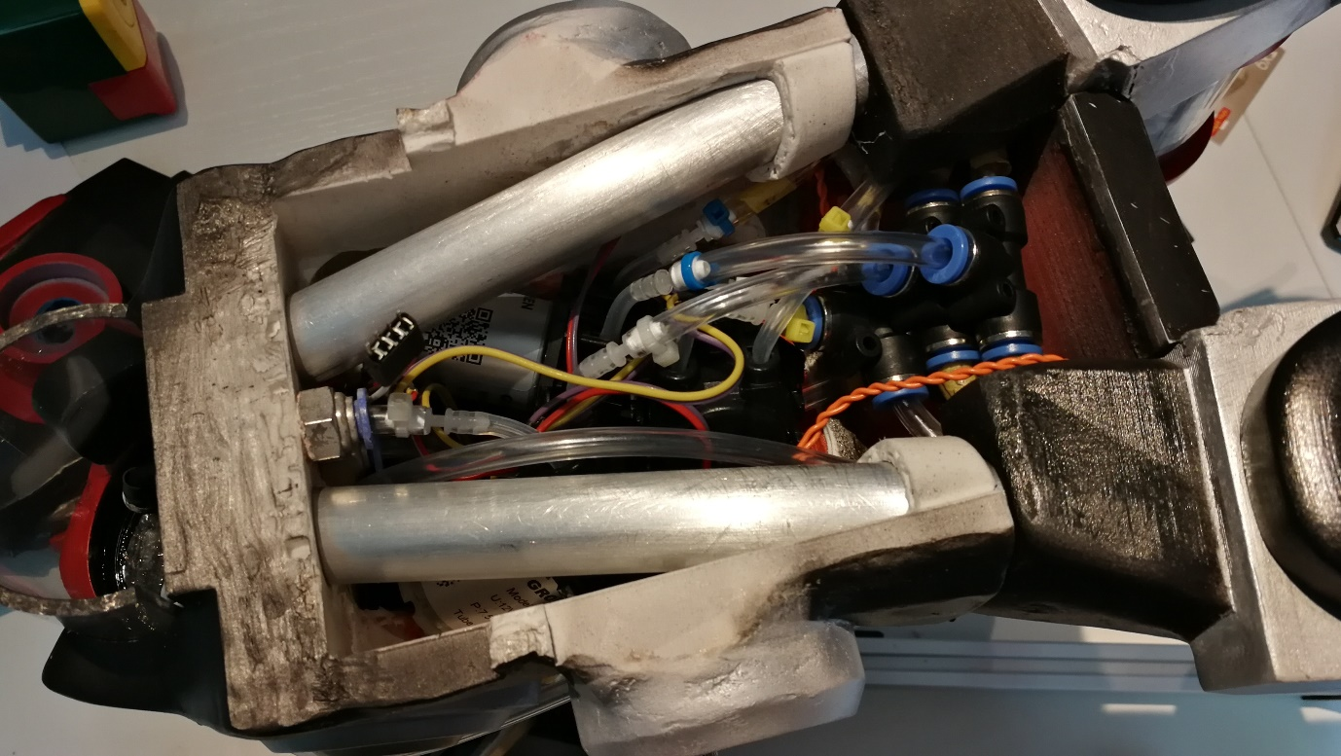

Figure 15,16,17,18:

(Top left) – Raw 3D printed part.

(Middle left) – Parts are glued together and filler is applied. Part is then sanded to a smooth finish.

(Bottom left) – Then the parts are airbrushed and painted.

(Right) – Finally a topcoat is applied to protect the part and to seal the paint.

Figure 14: Inside the model with all the wiring and plumbing connected. The display Arduino connects to the long wire leading away from the model.

# References/Technical Information

Chemical Plant Display and Teaching Model

User manual and more information: <https://github.com/NL-AE/Uni-Chemical-Plant-Code>

Video edited in Blender

Music “Divider” - Chris Zabriskie

Created by: Yuntian Fang

Supervisor: Dr Sai Gu

Date: 17th July 2020 / Rev 1.0

Figure 19: Exploded view of all the parts in the model.

Following describes the more technical details of the model including the code and how the model operates.

The code can be freely downloaded at my GitHub:

<https://github.com/NL-AE/Uni-Chemical-Plant-Code>

The following information is also available on the README file in the GitHub and is copied here for convenience.

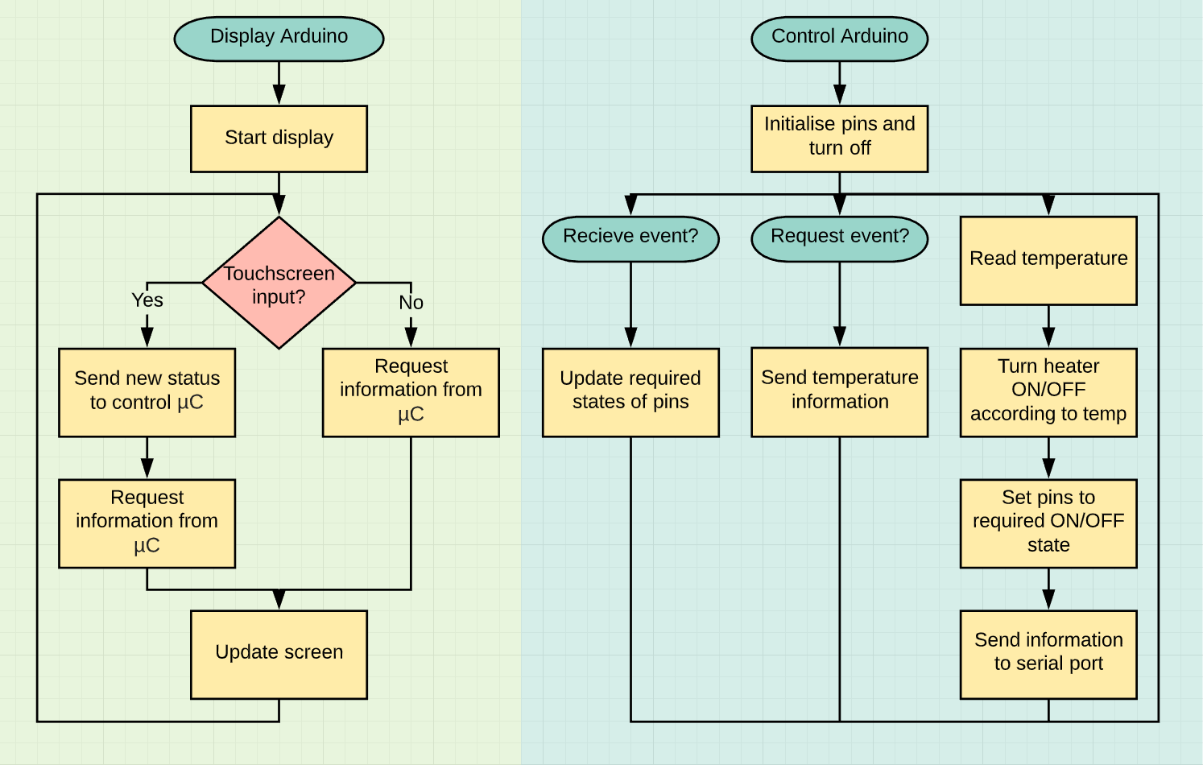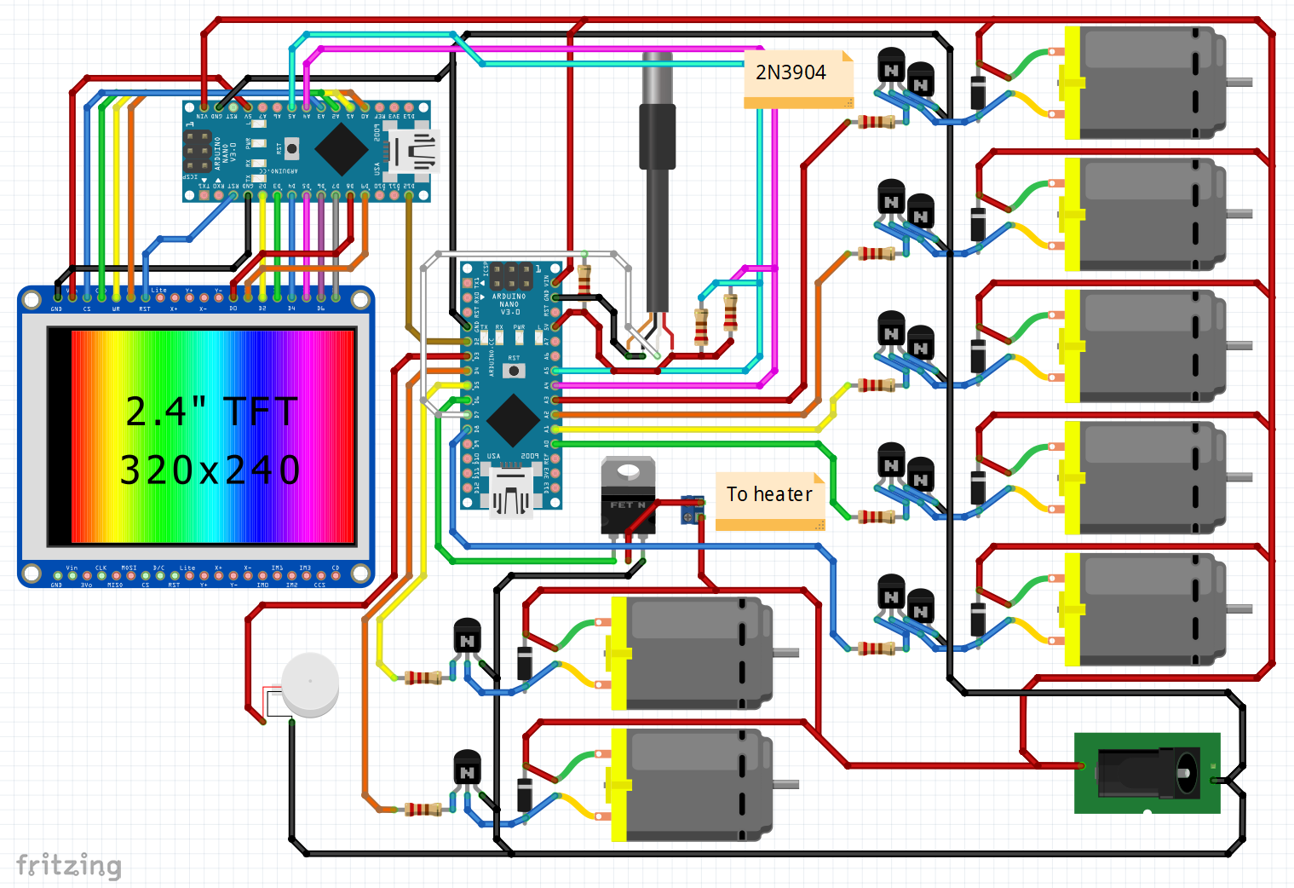

Figure 22: Full schematic of the control and display Arduino Nanos. Made in fritzing.

Figure 23: Decision tree of the individual Arduino Nanos.

# Revision Changes

# Revision 2 (written 6th Jul 2020)

* Changed wording of rule 4c on page 5 of 13.
* Added rule 4d on page 5 of 13.
* Added page 6 of 13 detailing start-up and shutdown sequence.